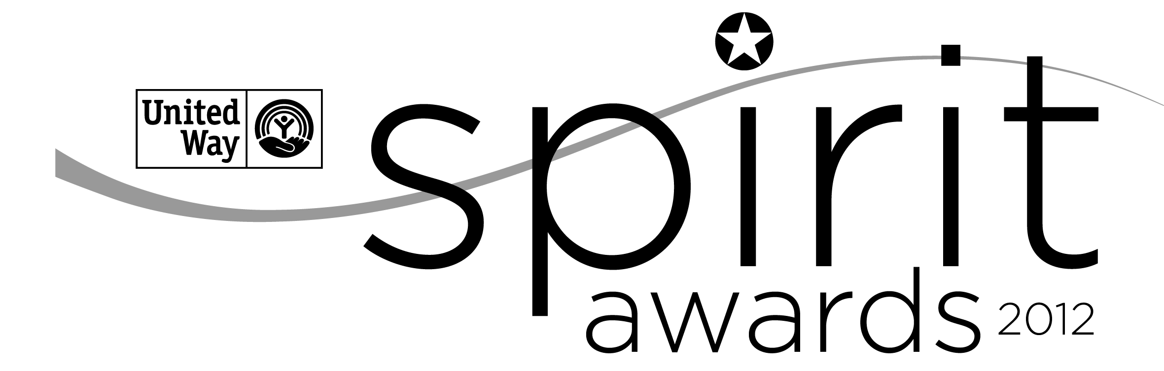
NOMINATION FORM

Spirit of the Midlands Award
For Corporate Leadership
2023-2024

An electronic version of this form can be accessed at www.uway.org. Download a copy of the word document to your computer. Once completed, please attach the file to an e-mail and submit to Jacqueline Campbell-Lawrence only at jlawrence@uway.org. Please be sure to put “Spirit Award Nomination Form” then company name in the subject line. If you have any letters of support you wish to provide, please scan them, and submit them in .pdf format along with the nomination form.

The Spirit of the Midlands Award for Corporate Leadership is presented to a corporate partner(s) that embodies an overall spirit of giving through contributions of time, leadership, and resources in support of United Way’s work in creating generational change by meeting immediate needs and building resilience. Companies are eligible to win only once every two years. The award will be presented at the Major Firms Breakfast in early May.

Nominee Information:
Company Name
☐ 10 - 499 employees
☐ 500 or more employees

Company Address
Company Contact Name
Telephone
E-mail

Nomination Completed By:
Name
Address
Telephone

E-mail

Please complete the following questions fully to give the selection committee the most important information about the nominee.

(35 points)
- COMMUNITY IMPACT: Over the past year (March 20 – March 22), how has this company played an active role LOCALLY and positively contributed to United Way’s work in creating generational change by meeting immediate needs and building resilience.
- If applicable, please include a summary of how this company’s philanthropic goals align with United Way’s work.
- How are all or one of your targeted impact areas supported through company investment such as grants?
- Describe additional support through in kind gifts, through leadership or pro bono support.

(20 points)
- VOLUNTEER ENGAGEMENT: Over the past year (March 20 – March 22), describe how this company exhibits a company-wide commitment to involving employees, families, retirees and other stakeholders in volunteer opportunities and service to benefit our community.

- Please explain how this company’s culture and policies encourage and recognize volunteering. Please include your company’s policy for employees volunteering during work hours.
- Please include in your response a description of the company and employees’ participation in volunteer projects with United Way. (Examples: United Way Volunteer Week, Midlands Reading Consortium, representation on United Way Board, Campaign Committee, other committees, or other United Way volunteer opportunities, etc.).
- Please include a description of the impact of volunteers.
o Number of volunteers
o Percentage of employees that volunteers
o Value of volunteer hours

- FINANCIAL SUPPORT: Over the past year (March 20 – March 22), describe the corporate and employee commitment to positively impact our community through corporate, employee workplace giving and sponsorship support.
(40 points)

The review Committee will also take into consideration the percentage of unrestricted support which will be pulled from records internally.

- Please include this company’s overall corporate and foundation contributions specifically invested in United Way and United Way partnerships.
- Please include how the company engages employees (and retires if applicable) in the workplace giving campaign and results.
- Describe the company’s support for leadership giving (including Tocqueville, Palmetto Society and Affinity Groups.)
- Please include how the company provides event or marketing support to United Way.

(5 points)
- Turn in application to Jacqueline Campbell-Lawrence by 5pm on the deadline:

Nominator Signature: (Please type in your name here. Your e-mail will serve as your signature.)

Submission Date

Thank you for your participation in the nomination process!
Please return the completed nomination form by March 29th, 2024, via e-mail to Jacqueline Campbell-Lawrence only at jlawrence@uway.org.

PAST WINNERS
2012-2013 Colonial Life
2013-2014 SCANA
2014-2015 McNair Law Firm, P.A.
2015-2016 Elliott Davis
2016-2017 AgFirst Farm Credit Bank
2017-2018 BlueCross BlueShield
2018-2019 Enterprise Holdings
2019-2020 Elliott Davis
2020-2021 AgFirst Farm Credit Bank
2021-2022 Elliott Davis
2022-2023 AgFirst Farm Credit Bank

