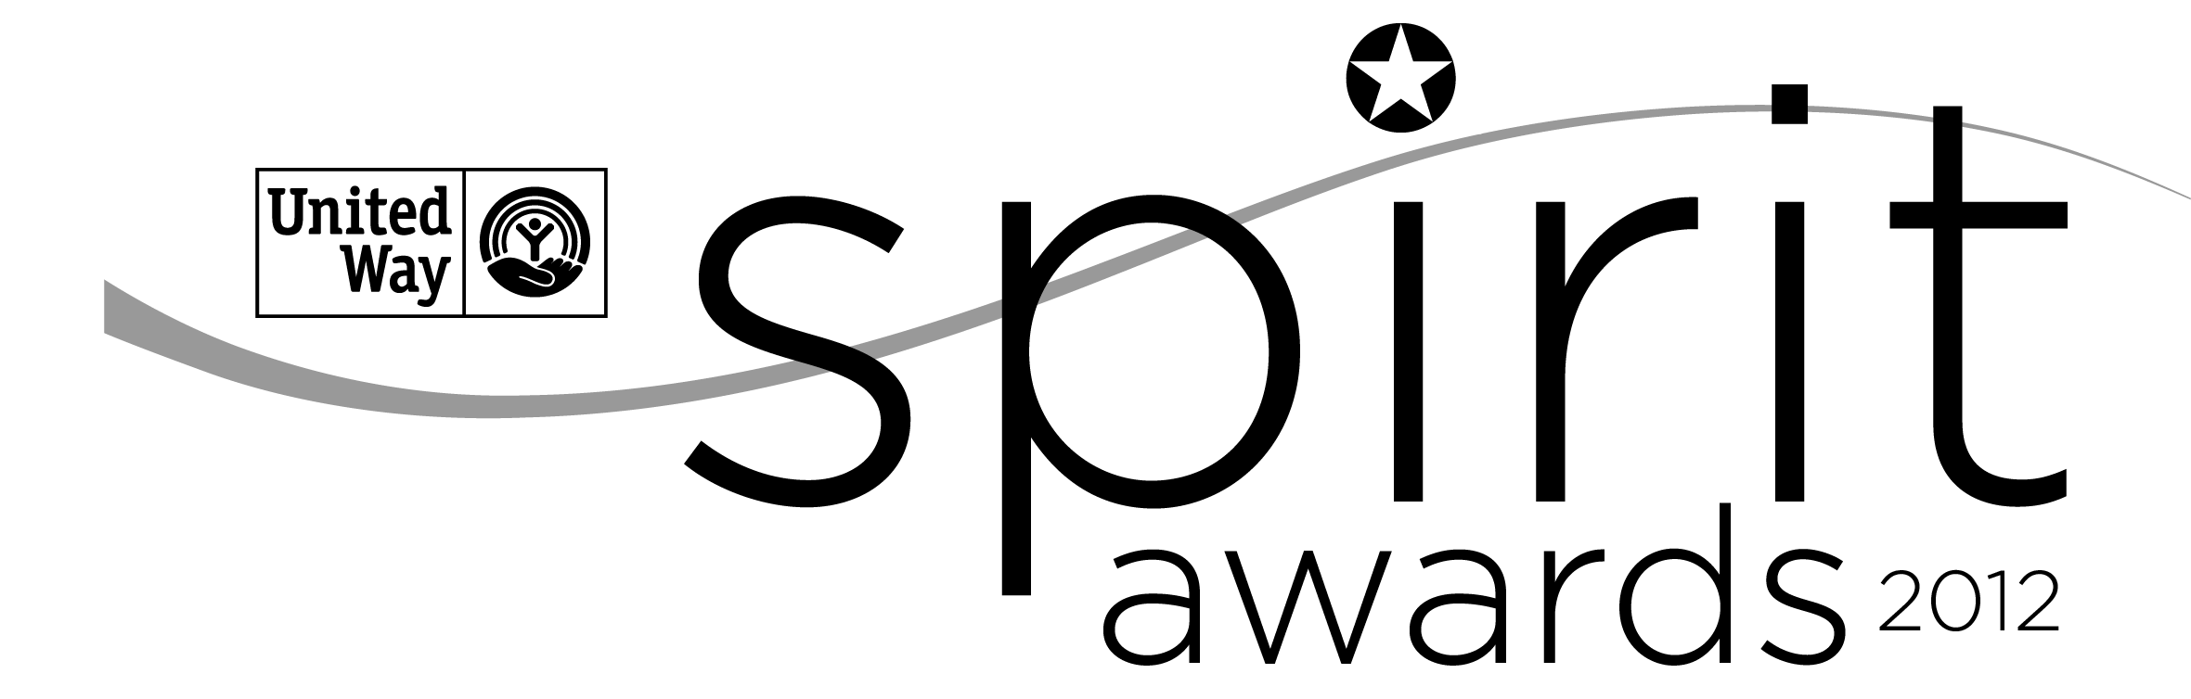
NOMINATION FORM

Spirit of the Midlands Award
For Corporate Leadership
2020-2021

An electronic version of this form can be accessed at www.uway.org. Download a copy of the word document to your computer. Once completed, please attach the file to an e-mail and submit to Jacqueline Campbell-Lawrence only at jlawrence@uway.org. Please be sure to put “Spirit Award Nomination Form” then company name in the subject line. If you have any letters of support you wish to provide, please scan them and submit them in .pdf format along with the nomination form.

The Spirit of the Midlands Award for Corporate Leadership is presented to a corporate partner(s) that embodies an overall spirit of giving through contributions of time, leadership and resources in support of United Way’s work in the priority issues of student success, financial stability and health access. Companies are eligible to win only once every two years. Depending upon the number of nominations the review team may select two awards based on company size. The award will be presented at the Major Firms meeting in early May.

Nominee Information:
Company Name
☐ 10 - 499 employees
☐ 500 or more employees

Company Address
Company Contact Name
Telephone
E-mail

Nomination Completed By:
Name
Address
Telephone

E-mail

Please complete the following questions fully to give the selection committee the most important information about the nominee.

(35 points)
- COMMUNITY IMPACT: Over the past year or 12-month period, how has this company played an active role LOCALLY and positively contributed to United Way’s work in improving student success, financial stability for families and individuals including homelessness & housing services, and programs to address hunger and health access.
- If applicable, please include a summary of how this company’s philanthropic goals align with United Way’s work in the areas of school readiness, financial stability and health access.
- How are all or one of your targeted impact areas supported through company investment such as grants?
- Describe additional support through in kind gifts, thought leadership or pro bono support.

(20 points)
- VOLUNTEER ENGAGEMENT: Over the past year or 12-month period, describe how this company exhibits a company-wide commitment to involving employees, families, retirees and other stakeholders in volunteer opportunities and service to benefit our community.

- Please explain how this company’s culture and policies encourage and recognize volunteering. Please include your company’s policy for employees volunteering during work hours.
- Please include in your response a description of the company and employees’ participation in volunteer projects with United Way. (Examples: United Way Day of Action, Flood Response, Midlands Reading Consortium, representation on United Way Board, Campaign Committee, other committees, or other United Way volunteer opportunities, etc.).
- Please include a description of the impact of volunteers.
o Number of volunteers
o Percentage of employees that volunteers
o Value of volunteer hours

- FINANCIAL SUPPORT: Over the past year or 12-month period, describe the corporate and employee commitment to positively impact our community through corporate, employee workplace giving and sponsorship support.
(40 points)

The review Committee will also take into consideration the percentage of unrestricted support which will be pulled from records internally.

- Please include this company’s overall corporate and foundation contributions specifically invested in United Way and United Way partnerships.
- Please include how the company engages employees (and retires if applicable) in the workplace giving campaign and results.
- Describe the company’s support for leadership giving (including Tocqueville, Palmetto Society and Affinity Groups.)
- Please include how the company provides event or marketing support to United Way.

(5 points)
- Turning Application in to Jacqueline Campbell-Lawrence by 5pm on the deadline:

Nominator Signature: (Please type in your name here. Your e-mail will serve as your signature.)

Submission Date

Thank you for your participation in the nomination process!
Please return the completed nomination form by April 5th, 2021 via e-mail to Jacqueline Campbell-Lawrence only at jlawrence@uway.org.

PAST WINNERS
2012-2013 Colonial Life
2013-2014 SCANA
2014-2015 McNair Law Firm, P.A.
2015-2016 Elliott Davis
2016-2017 AgFirst Farm Credit Bank
2017-2018 BlueCross BlueShield
2018-2019 Enterprise Holdings
2019-2020 Elliott Davis

