Feel free to use the following email templates during the final days of your campaign. You’re also welcome to replace the images below with any of our fact images.

Final Push (Send over the last three days over your campaign)

Subject: Three days left to give! Let’s show how much we care!

There are only three days left to give to United Way! Thanks to those of you who have already generously given. We’ve <<PROGRESS TOWARD GOAL>>, and our goal is <<GOAL>>. Let’s show our community how much we care with a strong final giving push!

Give Now <<INSERT HYPERLNK TO WEBPAGE >>

We’ll be sharing some stats over these last few days so you can see how your gift helps others. One of United Way’s focus areas is promoting economic mobility so that everyone can have a home, find a job, and provide for themselves and their families.

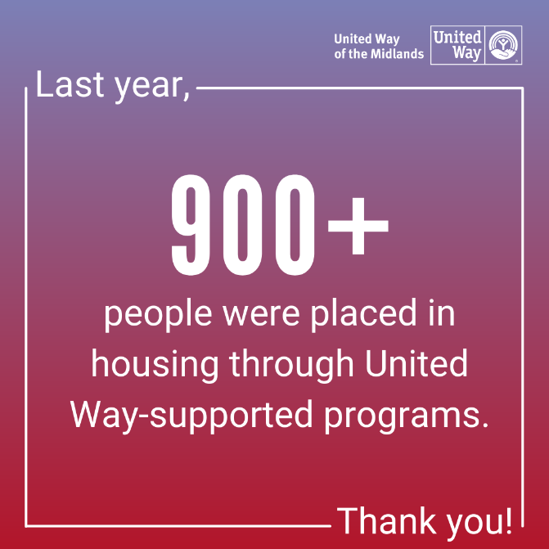

Help those in need get back on their feet so they can thrive!

Give Now <<INSERT HYPERLNK TO WEBPAGE >>

Thank you,

<<NAME>>

Subject: Two days left to give! We’re <<PROGRESS TOWARD GOAL>> from our goal.

There’s still time to give! With two days left, <<NUMBER>> people have donated, and we’ve <<PROGRESS TOWARD GOAL>>. We’re inching closer to our goal of <<GOAL>>, and we need your help!

Give Now <<INSERT HYPERLNK TO WEBPAGE >>

United Way provides children with a safe place to learn, after-school activities, mentors, books and summer programs to keep them on track to graduate and have a successful life.

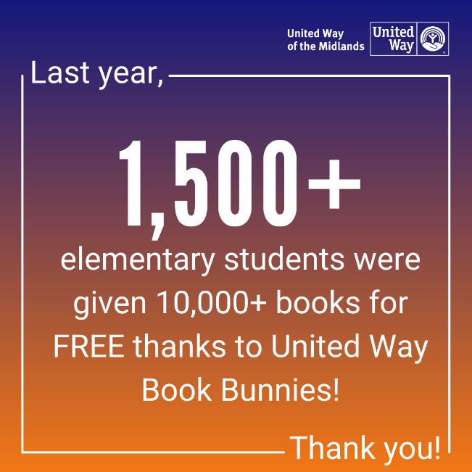

Help young kids gain the skills they need to find success in life!

Give Now <<INSERT HYPERLNK TO WEBPAGE >>

Thank you,

<<NAME>>

Subject: Last day to give! We're making a difference together.

Today’s the last day to give to United Way of the Midlands! We’re so grateful to everyone who’s donated time, effort, and financial gifts to this campaign. We’ve <<PROGRESS TOWARD GOAL>>, and our goal is <<GOAL>>. It’s your last chance to chip in and help out!

Give Now <<INSERT HYPERLNK TO WEBPAGE >>

United Way of the Midlands supports programs that provide quality health care, eye care and dental care to uninsured adults and children in the Midlands.

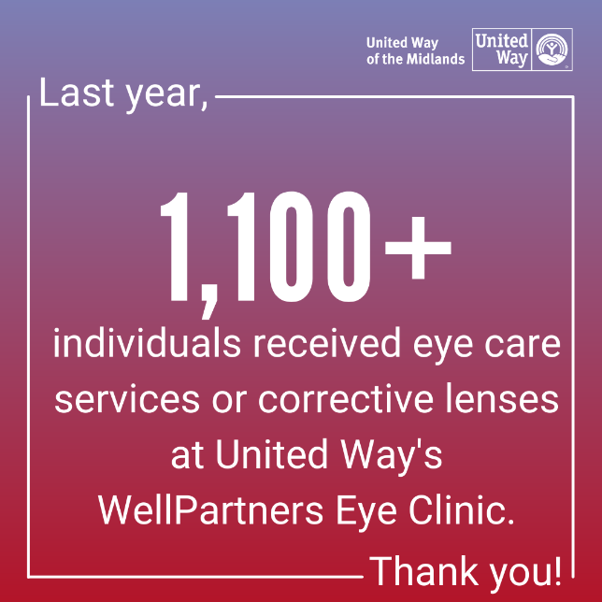

Help kids and families in need get free dental and vision care!

Give Now <<INSERT HYPERLNK TO WEBPAGE >>

Thank you,

<<NAME>>

